Charging a Card in POS/ROM/Units

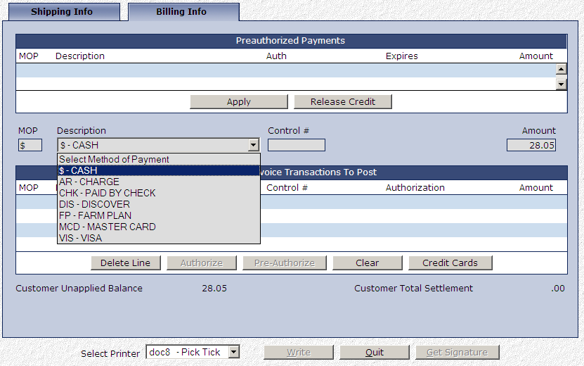

At the end of a ticket, after you have pressed the “Write” button, you can select a credit card as the method of payment.

- In the “Description” field, choose the type of card the customer wants to use from the drop-down menu.
  - If the customer wants to pay with credit, select the type of credit card.
  - If the customer wants to pay with debit, select “DEB-DEBIT CARD.”
  - NOTE: You will be unable to switch between debit and credit in EPIN, our credit-card charging application.
- Hit “Tab” on the keyboard until you pass through the dollar amount. EPIN will open in a new window.

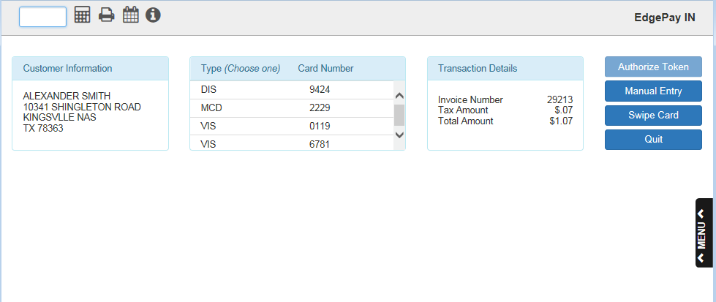

EPIN—Layout

- Customer Information: The Customer Information box displays the customer’s name and address.
- Transaction Details: The Transaction Details box displays the details of the transaction being paid for, which include:
  - The invoice number
  - The tax amount
  - The total amount

Charging a Card in EPIN: There are four different methods of charging a card in EPIN: three for credit cards, and one for debit cards. Charge a card using the blue buttons on the right side of the window.

- Credit Cards
  - Authorize Token: Use this method if the customer wants to pay with a token. NOTE: This button will not be accessible unless you are using a GPEP processor and the customer is paying with a public credit card.
    - Select the card you want from the list in the middle box. The chosen card will highlight in green.
    - Click “Authorized Token.” The program will run the card automatically without requiring any manual action.
    - When the signature is required, the program will prompt you to ask the customer for their signature (see below). The customer must sign their name on the terminal to complete the transaction.
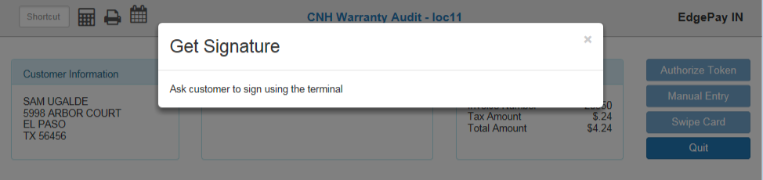

    - If the transaction is successful, a version of the following screen will display:

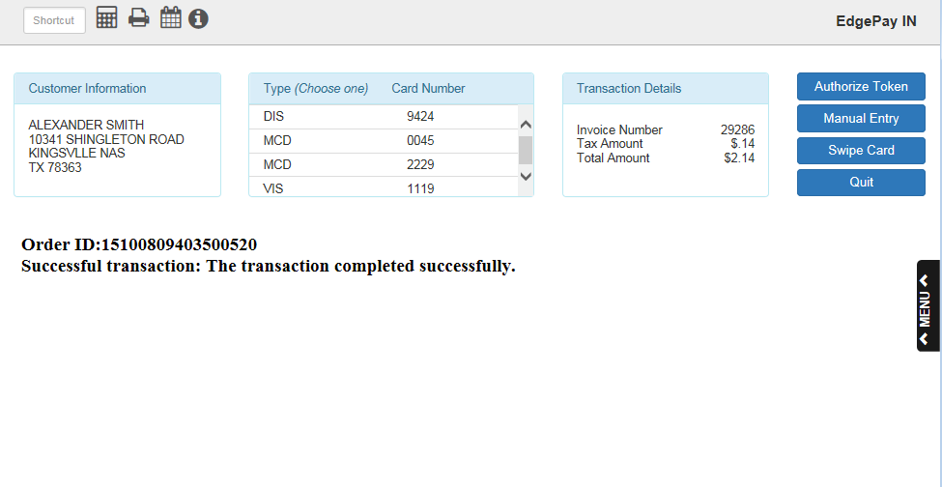

    - If the transaction is not successful, an error message will display. For example, if there is a problem with your merchant account, the following will display:
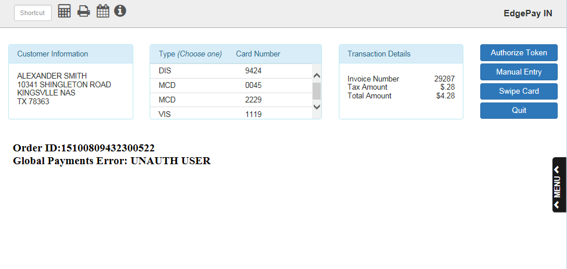

    - After a successful transaction, the program will return to the Invoice screen. The transaction will then be listed in the box titled “Customer Invoice Transactions To Post.”
  - Manual Entry: Use this method to charge the card by manually entering its information.
    - Click “Manual Entry.” The following screen will appear:

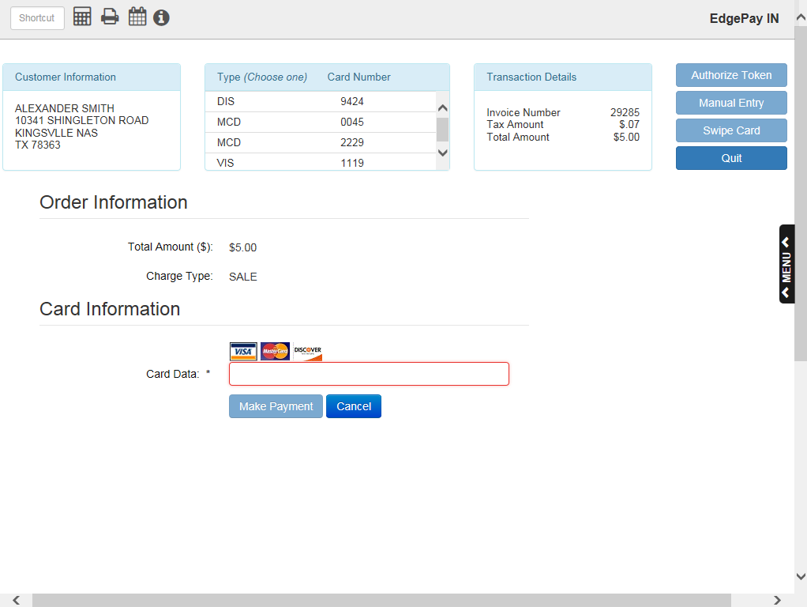

    - Begin typing the card number into the “Card Data” field.
    - The field will then change to “Card Number” and reveal the remaining information fields, as seen below:

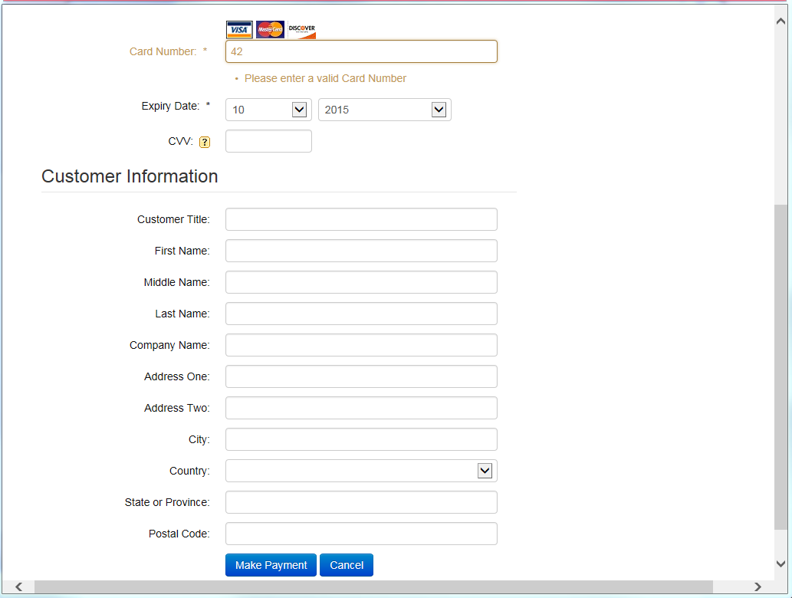

    - Finish typing in the card number. If the field accepts the card number, it will turn from red or yellow to green.
    - Select the card’s expiration month and year from the drop-down menus next to “Expiry Date.”
      - You can also enter the card’s CCV number and the customer’s information in the fields, though only the card number and the expiration date are required to complete the transaction.
    - Click “Make Payment.” The program will process the transaction and indicate that it was successful before returning to the Invoice screen. The transaction will then be listed in the “Customer Invoice Transactions To Post” box.
    - If the transaction does not go through, the screen will show an error message.
  - Swipe Card: Use this method to charge the card using a credit card terminal. NOTE: This is the method to use when running a Chip transaction.
    - Click “Swipe Card.” The screen will bring up the following image reading “Processing Through Terminal”:
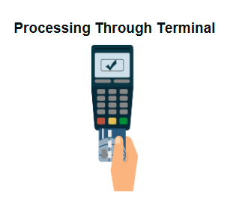
    - If for whatever reason the program is not properly connected to your terminal, an error message will appear. For example, “Connecting Remote Client Manager timeout” if you are not connected to Remote Client Manage, which runs your terminal software.
    - Process the card through the terminal.
    - When the signature is required, the program will prompt you to ask the customer for their signature. The customer must sign their name on the terminal to complete the transaction.
    - Once the transaction is completed, the program will show either that the transaction was successful, or an error message indicating it was unsuccessful.
    - The program will then return to the Invoice screen, where the successful transaction will show in the “Customer Invoice Transactions To Post” box.
- Debit Cards
  - Swipe Card: Use this method to charge the card using a credit card terminal. NOTE: This is the only method by which you can charge a debit card.
    - Click “Swipe Card.” If you try to process the card through any other method, the following error message will appear:

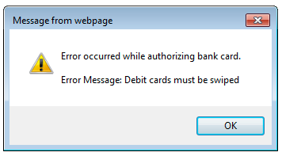

    - The program will bring up the “Processing Through Terminal” image. Process the card through the terminal.
    - The program will then show either that the transaction was successful or an error message indicating it was unsuccessful.
      - It may also show a screen requesting you to ask the customer for their signature. If this is required for the transaction through the terminal, make sure they sign.
    - If the transaction is successful, the program will return to the Invoice screen and show the successful transaction in the “Customer Invoice Transactions To Post” box.
  - NOTE: Not all debit cards will render an authorization number with the transaction. Some may simply say “Authorized.”

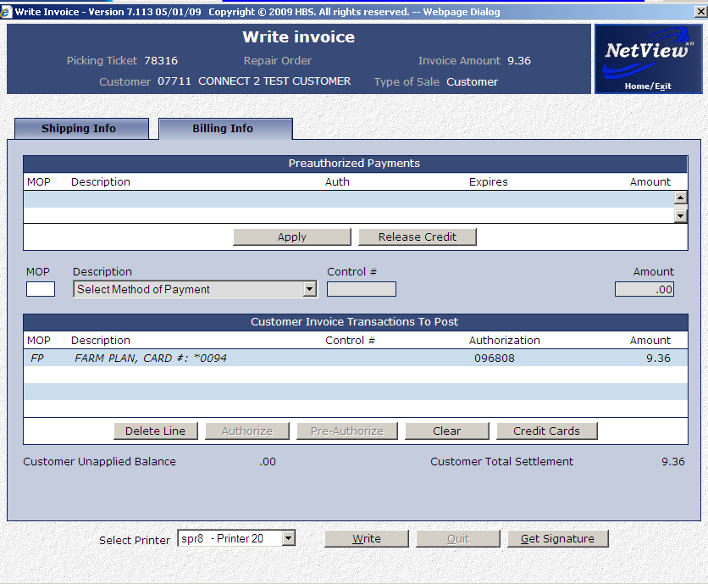

Double-Billing: In all cases, if you are about to double-bill a card for whatever reason, the system will automatically prevent you from doing so and show you an error message, such as “Duplicate Card Entry.”

Completing the Ticket: Once you have charged the card and been returned to the Invoice screen, click the “Write” button at the bottom of the screen to add the transaction to the ticket in POS.

Daily Transaction Log: Regardless of whether the transaction is successful or not, it will appear in the daily transaction log, which will automatically print out during the night after the end of a business day.

